
 Technical Design Document
Project name
Prepared for
Client name
05.10.2023
Version



Technical Design Document [TDD] 4
1. Scope of Work 4
1.1 Functional requirements 4
1.2 Non-functional requirements 4
1.2.1 Scalability 4
1.2.2 Performance 4
1.2.3 Reliability 5
1.2.4 Security 5
1.2.5 Data integrity 5
1.2.6 Monitoring and Logging 5
1.2.7 Data Backup and Restore 6
1.2.8 Compliance 6
1.2.9 Fault Tolerance 6
1.2.10 Cost Efficiency 7
1.2.11 Reusability 7
2. Guidelines / Best practices 7
3. System Component – AS-IS 8
4. System Component – TO-BE 8
5. Naming Conventions System Component – To-BE 9
5.1. Source File Staging bucket 9
5.2. GLUE JOBS 9
5.3. Custom files 9
6. System Component – AS-BE 10
6.1. Amazon S3 10
6.2. AWS GLUE 10
6.3. AWS ECS 10
6.4. AWS LOAD BALANCER 11
6.5. SNS (SIMPLE NOTIFICATION) 11
7. Logical Architecture 11
8. Data Model Information For RDS: 12
9. Data Ingestion 16
9.1. Data organization in Amazon S3: 16
9.2. Ingestion Process using Glue Jobs: 17
9.3. Data storage in Data Lake and Data Retention: 17
Data related error handling. 19
9.4. Data correction: 19
9.5. Try-Catch Mechanism: 19
9.6. Logging: 19
9.7. Error Notification: 19
9.8. Data Validation: 19
9.9. Reject Data: 19
9.10. Error Code: 19
9.11. Transaction Rollback: 20
9.12. Constraint Violations: 20
9.13. Retry Logic: 20
Config file technical considerations and set up. 20
10. Detailed design of the modules. 22
10.1. ETL process logic 22
10.1.1. Logging and Error handling 23
10.1.2. Security Considerations: Secret Rotation: 24
10.2. Threshold Module: 24
10.3. Task and Trigger Module 25
PROCESS OVERVIEW 25
10.4. Closure Module 27
10.5. Optimization 28
10.6. API and UI: TBD 28
10.7. Config Validation 28
10.7.1. Threshold logic Config 28
10.7.2 Source Code 29
11. IEARN CI/CD Setup. 34
12. Job Scheduling – NA 35
12.1. Code Repository and branching 35
13. Code Repository and branching 35
13.1. Branching 35
14. AWS Job scheduling and rerun: 36
15. Job Run Frequency: 36
16. Appendix: 36

Technical Design Document [TDD]

This document includes technical design for HDFC I Earn project. The document would serve as key input to the build/ testing phase ensuring the development aligns with project requirements, follows best practices and adheres to HDFC data factory guidelines.

Scope of Work

Functional requirements
The scope of the project encompasses the redesign and redevelopment of efficient data pipelines (ELT) to transfer and store the data from external sources into AWS cloud. The data will be extracted from the data sources mentioned below and stored in the s3 data lake in the required file formats in various specified folders. The scope is as follows:
- Platform should be able to support batch processing of data for daily reporting purpose.
- Platform should be able to store final data into RDS for the end users to access for reporting and display into mobile devices.

Non-functional requirements

Scalability
- Auto-scaling: Set up automatic scaling policies in glue to adjust resources dynamically based on real-time traffic and utilization.
Using server less glue job which auto scales as per requirements.
Initial Run (6 GB of Data): For the initial ETL job that processes 6 GB of data, you may consider starting with a moderate DPU allocation, such as 10 to 20 DPUs. This will provide sufficient compute power to process the larger dataset more quickly. Subsequent Daily Runs (100 MB of Data): For the daily runs where the data volume is only 100 MB; you can reduce the DPU allocation significantly. Starting with 2 to 5 DPUs should be sufficient to process this smaller dataset efficiently.
- Database Scaling: Implement strategies for scaling the database tier to handle larger data volumes and higher query loads. Planning to have an extra read replica in case of heavy concurrent requests.
- Load Balancing: Use load balancers to evenly distribute requests coming from APIs.

Performance
- Response Time: Ensure that API requests, ETL processes, and UI interactions have response times within acceptable limits for user interactions.
- Throughput: Define the maximum number of requests or data records that the system should handle per unit of time, supporting the expected load.
- Resource Utilization: Use auto upgradation feature of the glue job which is server less.
- ETL Processing Speed: Specify the speed at which ETL processes should transform and load data, meeting defined processing windows.

Reliability
- Uptime: Define the target uptime percentage (e.g., 99.9%) and establish procedures for maintenance windows.
- Redundancy: Implement redundancy and failover mechanisms to ensure service availability in case of hardware or software failures.
- Backup Frequency: Specify how often data backups should occur and the retention period for backups.
- Disaster Recovery: Develop and test a disaster recovery plan to recover the system in the event of catastrophic failures.
- Fault Isolation: Ensure that failures in one component or module do not lead to system-wide outages.

Security
- Access Control: Define role-based access control (RBAC) and permissions to restrict access to sensitive data and functionality.
- Data Encryption: Encrypt data at rest and in transit using industry-standard encryption algorithms.
- Authentication: Implement multi-factor authentication (MFA) for user accounts and ensure secure user authentication.

Data integrity
- Data validation and cleansing should ensure a data accuracy rate of at least <99.5%>.
- Duplicate data should be minimized, with an allowed duplicate rate of less than <0.5%>.
- Data lineage should be tracked to ensure traceability from source to target.

Monitoring and Logging
- All logs should be retained for at least <90> days.
- Monitoring tools should be able to detect and alert for critical issues within <5> minutes.
- Log analytics should be performed to identify trends and potential issues proactively.
- Log data should be available for analytics with third party tools.

Data Backup and Restore
- Backup Frequency: Define the frequency of data backups, considering the criticality of the data and the potential for data loss.
- Backup Verification: Regularly verify the integrity of backup data to ensure it can be successfully restored when needed.
- Backup Storage: Store backups in geographically dispersed and secure locations to mitigate the risk of data loss.

Compliance
- Compliance Auditing: Implement mechanisms for auditing and reporting compliance with relevant regulations, including regular compliance assessments.
- Data Handling: Define procedures for compliant data handling, including data retention and deletion policies as required by regulations.
- Access Controls: Enforce access controls and permissions to ensure that only authorized personnel can access sensitive data or perform regulated actions.
- Compliance Training: Provide compliance training and awareness programs for staff involved in system operations to ensure they understand and follow compliance requirements.

Fault Tolerance
- Redundancy: Implement redundancy for critical system components, such as load balancers, databases, and application servers, to ensure availability in case of hardware or software failures.
- Load Balancing: Use load balancing to distribute traffic evenly and avoid overloading specific components, reducing the risk of failure due to excessive load.
- The Recovery Time Objective (RTO): RTO represents the maximum acceptable downtime or the time it takes to recover from a failure and resume normal operations. The RTO for your scenario can vary depending on the criticality of the data processing tasks.
Initial Run (6 GB of Data):
Since the initial run is likely an infrequent or one-time operation, the RTO may be relatively flexible. The monthly job should be run by the end of the day.
Subsequent Daily Runs (100 MB of Data):
For the daily runs, where processing 100 MB of data is a routine task, RTO will be 6 hours. So, the job to be run again within 6 hours of failure.

- Recovery Point Objective (RPO): RPO represents the maximum acceptable data loss in case of a failure. It defines how much data you can afford to lose before it impacts your operations.
Initial Run (6 GB of Data):
For the initial run, where you're processing a large volume of data we will not have any RPO here as data is in data lake. the job can be rerun.

Subsequent Daily Runs (100 MB of Data):
The RPO for the daily runs can be much lower. Since these are recurring tasks so it can be one day.

- High Availability Architecture: The system architecture is designed to provide high availability by minimizing single points of failure.

Cost Efficiency
- Resource Monitoring: Continuously monitor resource utilization and costs to identify opportunities for optimization. By setting threshold alerts in price matrix.
- Auto-scaling: Implement auto-scaling policies to dynamically adjust resource allocation based on workload, reducing unnecessary costs during low traffic periods.
- Resource Rightsizing: Regularly review and right size AWS resources to match actual usage and avoid over-provisioning by the help of devops .

Reusability
- At least <xyz>of the ETL pipeline code should be reusable across different components and data sources. Addition of any extra channel or task will not require much code change.
- Common functions and libraries should be centralized and shared across the pipeline to reduce duplication and simplify maintenance.
- Best practices for code reuse and modular design should be documented and enforced across the development team.

Guidelines / Best practices

- Reusability – need to build generic code modules as much as possible.
- Performance – the job/transformation design should be most optimum from performance perspective.
- Naming convention
- Always use ‘small case’ for all objects/folders/files/variables etc
- Date format should be yyyymmdd while using in file/folder names etc
- All the timestamps should be kept in the UTC timezone, example timestamp included into file name.
- Follow enterprise datafactory standards for development
- Every ETL/code module/file should have comment as per standard format -
- Author – name [example rahul_arshad]
- Date of creation – yyyy-mm-dd
- Description – include purpose of code module and high-level approach/logic

System Component – AS-IS
 | Tool / Technology Name | Purpose
1 | S3 | Storing source system data. Also, facts/dimension tables after transformation.
3 | Lambda | For ETL processes
4 | Dynamo DB | Data warehousing
5 | Loadbalancer | Evenly distribute the API traffic
6 | SNS | For email n  otification
7 | API gateway | For communication with application

System Component – TO-BE

 | Tool / Technology Name | Purpose
1 | S3 | Storing source system data. Also, facts/dimension tables after transformation.
3 | AWS Glue | For ETL processes
4 | RDS | Data datastorage
5 | SNS | For email notification
7 | CloudWatch | For job logs and monitoring
8 | Code pipeline | CICD tool (AWS codepipeline /code deploy/CFT)
9 | Qlik | For reporting
10 | Load balancer | For balancing the request application load balancer.  Network load balancer: - route -53
11 | ECS | For containerization

Naming Conventions System Component – To-BE

Source File Staging bucket

s3-iearn-dev-stg 001/sources/iearn/<sourcename>/<modulename>/<filename>(input,confif,temp,etl,)

<sourcename> | <filename>
/DATALAKE | iearn_datalake_modulename_timestamp.parquet
/EDW | iearn_edw _tablename_timestamp.parquet

Examples of folder path under [/iearn/] folder

GLUE JOBS
The glue jobs will follow the below naming conventions:

iearn_gl_<module_name>_<job_name>
Example: iearn_gl_tnt_<job_name>

<module_name > | <job_name>
/tnt | iearn_gl_tnt_<job_name>
/etl | iearn_gl_etl_<job_name>
/closure | iearn_gl_closure_<job_name>
/optimization | iearn_gl_optimization_<job_name>
/threshold | iearn_gl_threshold_<job_name>

Custom files

The custom files will follow the following nomenclature:
<module_name>_<date>.<file format>
Custom files are the files designed for the following purpose:
- These are both input file and reference file for different modules
- User or stake holders can interact with the system by means of these files

Ex: Threshold Logic _01012023.csv
Task_trigger_01012023.csv
Closure_01022023.csv
Optimization.csv
5.4. Configuration_File :
Iearn_<file_name>_<format>
These files are used in the development process to store frequently used constant values.
Ex: Iearn_config.ini

System Component – AS-BE

Amazon S3
An object storage service that provides scalability, security, and performance for storing and protecting any amount of data, serving millions of customers worldwide. Its use cases include building running cloud-native apps, backing up and restoring critical data, and archiving data at low cost. S3 is designed for high durability and provides robust replication features for meeting compliance requirements. Its low-cost storage classes, S3 Glacier and S3 Glacier Deep Archive, eliminate operational complexities.

AWS GLUE
A server less data integration service that allows users to integrate data from multiple sources easily, and prepare it for analytics, machine learning, and application development. The service consolidates various data integration capabilities, including data discovery, modern ETL, cleansing, transforming, and centralized cataloguing, into a single service. AWS Glue integrates with various AWS analytics services and Amazon S3 data lakes and supports all workloads like ETL, ELT, and streaming. It is a scalable and cost-effective service with built-in high availability and pay-as-you-go billing, suitable for users with varying technical skill sets.

AWS ECS

A managed container orchestration platform. It simplifies deploying, managing, and scaling Docker containers. ECS uses task definitions to define container configurations, runs tasks on clusters of EC2 instances or with AWS Fargate, and integrates with load balancing, auto scaling, and monitoring services for efficient containerized application deployments.

AWS LOAD BALANCER

An AWS load balancer is a service that distributes incoming traffic across multiple instances of an application, improving scalability, availability, and reliability. It can be configured to route traffic based on various factors such as geographic location, load, and SSL termination. Common use cases include distributing traffic across multiple instances of a web server, load testing, and disaster recovery. Distribute incoming traffic, enhance fault tolerance, and ensure high availability by routing traffic to healthy resources. They are a fundamental component of building scalable and reliable applications in the AWS cloud. The choice of load balancer type (ALB, NLB, or CLB) depends on your specific use case and requirements.

SNS (SIMPLE NOTIFICATION)

It is a fully managed messaging service provided by Amazon Web Services (AWS). It enables the distribution of messages or notifications to a large number of subscribers, including applications, users, and other services. SNS is designed to simplify the process of sending messages to a variety of endpoints in a reliable and scalable manner.

Logical Architecture

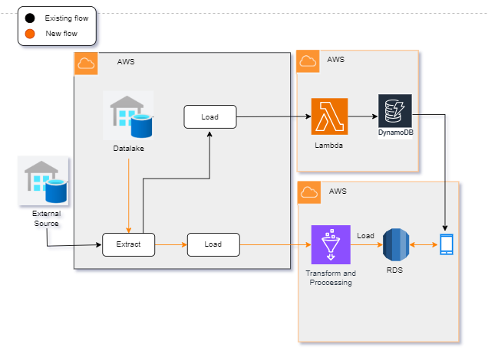
**Previous Architecture:**
In the previous architecture, data extraction was conducted from an external source, and the data was initially loaded into DynamoDB using AWS Lambda functions. This architecture involved a direct data flow from the external source to a NoSQL database. However, it was limited in terms of data transformation and querying capabilities.

**New Architecture:**
In the new architecture, data extraction occurs from a data lake, and AWS Glue is employed for ETL (Extract, Transform, Load) processes. The data is first loaded into Amazon S3 and subsequently into an RDS (Relational Database Service). This RDS-hosted data is made accessible to mobile applications via AWS Lambda functions and API endpoints, enabling more flexible querying and structured data storage. This architecture enhances data processing capabilities and supports improved querying for the mobile app.

File details in S3 Bucket and RDS:

Lead_data

COLUMN_NAME | DATATYPE | KEY_DETAIL
lead_id | int | pk
application_id | int | fk
application_login_date | date
application_status | varchar
billing_frequency | int
combo_flag | bool
epi | int
first_meeting_held_date | date
first_meeting_scheduled_date | date
fls_id | int | fk
fyfp | int
latest_meeting_held_date | date
latest_meeting_scheduled_date | date
lead_generation_date | date
lead_generation_source | varchar
lead_status | varchar
num_riders | int
open_flag | bool
pcvc_requirement_completion_date | date
pcvc_status | varchar
tat_medi_fr_clsr | int
tat_nonmedi_fr_clsr | int
tat_single_nonmedi_fr_clsr | int
lead_aging | Int

Policy_table

COLUMN_NAME | DATATYPE | KEY_DETAIL
policy_number | Int | Pk
application_id | Int
application_login_date | date
billing_frequency | Int
combo_flag | bool
epi | int
fls_id | Int | fk
fyfp | int
lead_generation_date | date
lead_id | Int | fk
lookin_cancellation_aversion_date | date
lookin_cancellation_request_date | date
lookin_cancellation_request_status | varchar
num_riders | Int
paid_to_date | date
payment_mode | varchar
policy_first_receipt_date | date
policy_issuance_date | date
policy_status | varchar
updated_dttm | date

Optimized_data

COLUMN_NAME | DATATYPE | KEY_DETAIL
application_id | int | pk
channel | varchar
demogseg | Int
epi | int
fls_id | int
lead_id | int | fk
num_riders | int
open_flag | bool
policy_issuance_date | date
policy_number | int
subchannel | varchar
task_no | int
task_status | varchar
updated_dttm | datetime
valueseg | int
task_complete_date | date
Unique _value | varchar

Fls_details

COLUMN_NAME | DATATYPE | KEY_DETAIL
fls_id | int | pk
fls_date_of_joining | date
updated_dttm | datetime
persistency_13_months | int
lead_id | int | fk
policy_number | int
first_name | varchar
last_name | varchar
channel | varchar
subchannel | varchar
demogseg | varchar
valueseg | number

FR_data

COLUMN_NAME | DATATYPE | KEY_DETAIL
lead_id | int | uk
application_id | int
fr_application_status | varchar
fls_id | int
fr_generation_date | date
fr_med_nonmed | bool
fr_status | varchar
updated_dttm | datetime
fr_close_flag | bool
fr_open_flag | bool
single_flag | bool
single_non_med_flag | bool

Class Diagram: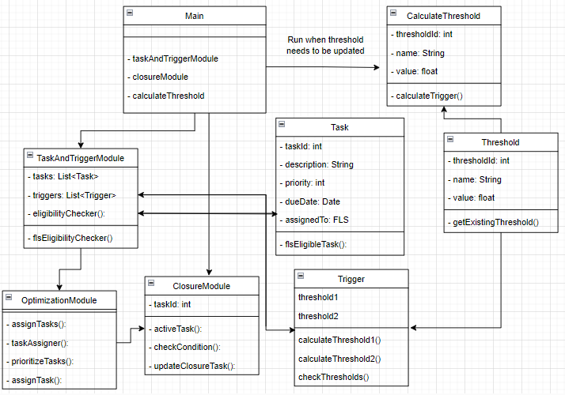
Class diagram for iEarn project
TaskAndTriggerModule | tasks: A list that contains instances of tasks to be managed.  triggers: A list that contains instances of triggers associated with tasks.  eligibilityChecker(): A method that checks the eligibility of tasks for assignment.  flsEligibilityChecker(): A method that checks the eligibility of Field Sales Agents (FLS) for tasks.
Main | taskAndTriggerModule: An instance of TaskAndTriggerModule responsible for managing tasks and triggers.  closureModule: An instance of ClosureModule responsible for managing task closures.  calculateThreshold(): A method that runs when thresholds need to be updated.  Run when threshold needs to be updated: A comment indicating the trigger condition for threshold calculation.  getExistingTrigger(): A method to retrieve an existing trigger.
CalculateThreshold | thresholdId: An integer representing the unique identifier for the threshold.  name: A string describing the threshold.  value: A floating-point value indicating the threshold value.  getExistingTrigger(): A method to retrieve an existing trigger.
Task | taskId: An integer representing the unique identifier for the task.  description: A string describing the task.  priority: An integer indicating the task's priority.  dueDate: A Date object representing the deadline for the task.  assignedTo: A reference to an FLS object indicating the assignment of the task to an FLS.  flsEligibleTask(): A method that checks the eligibility of an FLS for the task.  threshold1: A threshold value for the task.  threshold2: Another threshold value for the task.
Trigger | calculateThreshold1(): A method that calculates the first threshold value.  calculateThreshold2(): A method that calculates the second threshold value.  checkThresholds(): A method that checks if triggers meet specified thresholds.
ClosureModule | taskld: An integer representing the unique identifier for the task.  activeTask(): A method that checks the status of tasks.  checkCondition(): A method that checks a condition.  updateClosureTask(): A method that updates task closure information.
OptimizationModule | assignTasks(): A method responsible for assigning tasks.  taskAssigner(): A method that assigns tasks to eligible FLS.  prioritizeTasks(): A method that prioritizes tasks.  assignTask(): A method that assigns tasks.
Threshold | thresholdId: An integer representing the unique identifier for the threshold.  name: A string describing the threshold.  value: A floating-point value indicating the threshold value.  getExistingThreshold(): A method to retrieve an existing thresh

Data Ingestion

Certainly, here's a more detailed explanation of how data from the Enterprise Data Warehouse (EDW) will be organized in folder formats within Amazon S3, and how the ingestion process will be performed using Glue jobs:

Data organization in Amazon S3:

Within the Amazon S3 storage environment, data from the EDW will be meticulously organized into a structured folder hierarchy. This hierarchy will reflect the logical organization of data, making it easy to locate and manage specific datasets.
Each folder within S3 will correspond to a specific category, dataset, or source of data. For example, you might have folders named after departments, projects, data sources, or dates, depending on your data organization strategy.
Subfolders can be used for further granularity, enabling a well-structured and easily navigable repository for the stored data.
By organizing data into folders in S3, data engineers and analysts can quickly identify and access the data they need without wading through a cluttered or unorganized data lake.

Ingestion Process using Glue Jobs:

Glue, a fully managed ETL (Extract, Transform, Load) service offered by AWS, will be used to facilitate the ingestion process. Glue jobs are server less, meaning they automatically handle the infrastructure, scaling, and execution of data transformation tasks.
Glue jobs will be created to extract data from the EDW and load it into the appropriate folders within S3. These jobs will be designed to perform data extraction efficiently while adhering to the defined data schema and quality checks.
The ETL process can include transformations and data enrichment as necessary. This may involve cleaning, aggregating, or enriching the data before storing it in S3.

Data storage in Data Lake and Data Retention:

Root Directory: s3-iearn-dev-stg-001 is the root directory or storage location.
IEARN Folder: Inside the root directory, there is a <project name>directory which
Contains folder for the specific purpose.
Input folder: This is resting place of input raw data post transformation. Retention period of data: minimum 24 hours maximum 6 months
Along with this if any other input data is required for the pipeline to process will reside here in this bucket.
Custom files are going to reside in this folder along with glue jobs
Config Folder: This folder will hold the config files and the util files required for project development purpose. Retention period of data: forever
Temp folder: This will contain all intermediary files and will serve as temp location for glue job. Retention period of data: maximum 24 hours.
File Name: <filename> is the actual name of the file, and it can take various forms such as input, config, temp, or etl. Depending on its purpose, it may contain data, configuration settings, temporary files, or files related to the Extract, Transform, Load (ETL) process.

Folder structure for input file
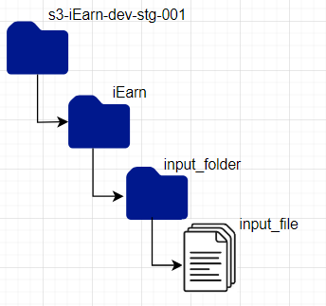

Folder structure file config
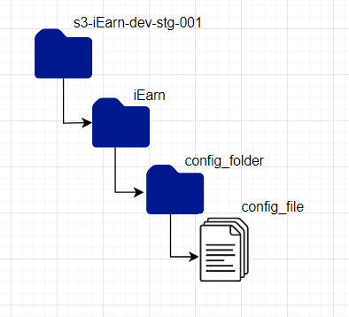

Folder structure temp file
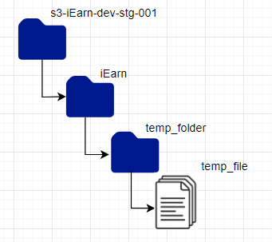

Folder/Bucket | Contents | Retention Period
S3-IEarn-dev-stg-001 | temp/input/config/ | permanent
Temp folder | Glue temp location and intermediary files | Glue temp - permanent  Intermediary files – maximum 24 hrs
Config folder | Config file | Permanent
Input folder | Custom files,glue job code,transfermed input data | Custom file – uncertain  Glue job file –permanent  Input data – 24 hrs

Data related error handling.

Data correction:
A process for rectifying identified data errors will be integrated into our system. This process involves the removal of corrupted data. Corrupted data can be addressed through manual intervention within the source system, or by applying predefined validation rules before data transformation.

Try-Catch Mechanism:
In the Glue jobs, a try-catch mechanism will be employed to effectively capture and manage errors. In the event of an error during data extraction or transformation, the catch block will be utilized to log the error, transmit notifications, and potentially initiate retries for the operation.

Logging:
We will utilize Glue's built-in logging capabilities to meticulously document errors. Log essential information, including the error message, timestamp, and details about the affected data. These logs can be stored in a dedicated location within Amazon S3 or transmitted to CloudWatch for in-depth analysis.

Error Notification:
We are Implementing error notification mechanisms using AWS SNS (Simple Notification Service). We will set up SNS topics to send alerts to designated recipients via email when errors occur. These notifications can include information about the error type, job ID, and more.

Data Validation:
A separate preprocessing validation code is written which will alert us relating to syntactical error, other nontechnical error and handle erroneous or inconsistent data. We are also checking for issues such as missing values, data type mismatches, or out-of-range values.

Reject Data:
A script is written to segregate erroneous or invalid data from valid data during the transformation process. Rejected data can be stored in a separate location for further analysis or manual review.

Error Code:
Assign error codes to different types of errors encountered during data transformation. Maintain a reference document that explains the meaning of each error code and possible resolution steps.

Transaction Rollback:
If you are loading data into an RDS database, ensure that you use transactions. In case of any errors during the insertion of records, you can roll back the transaction to maintain data consistency.

Constraint Violations:
Handled integrity constraints and unique key violations gracefully in code. Logging these errors and consider implementing mechanisms to either skip conflicting records or update them with corrected data.

Retry Logic:
For transient errors, such as temporary network issues or database connection problems, implemented retry logic, retry option in our glue job andretry failed database operations.

Config file technical considerations and set up.

Our proposal involves managing configuration and custom files in the form of CSV files, with each CSV file representing an input sheet. These files will be stored in the dedicated "dev input" folder within Amazon S3. When modifications are required for rules, tasks, or trigger conditions, these changes are first implemented in the development (dev) environment. In this environment, the Config/Custom File Manager can thoroughly verify the changes using sample data. Once the changes are validated in dev, they are seamlessly integrated into the production (prod) environment through a Continuous Integration/Continuous Deployment (CI/CD) process. To ensure a smooth transition, these changes should ideally be implemented one day before the scheduled threshold job runs in the production environment. This process ensures that configurations are thoroughly tested and ready for production use, promoting efficiency and reliability in data management.
S3 Buckets:
- A single S3 bucket is used for storing configuration and custom files for both dev and prod environments.
- Logical separation of data is maintained using prefixes (folders) for each environment (e.g., "dev" and "prod").
File Management:
- CSV Files:
  - Configuration and custom files are stored in CSV format, with one CSV file for each input sheet.
  - Each CSV file represents rules, tasks, or trigger conditions.
Development Environment:
- Dev Input Folder:
  - Within the S3 bucket, a dedicated "dev input" folder is created to store configuration files for the development environment.
CI/CD Pipeline:
- Continuous Integration/Continuous Deployment:
  - A CI/CD pipeline is established for promoting changes from the development environment to the production environment.
  - The pipeline is designed to automatically deploy configuration changes, including CSV files, from dev to prod.

- Job:
  - A scheduled threshold job runs in the production environment based on a predefined schedule.
Technical Workflow:
Configuration Changes (Dev):
- Configuration changes are initiated in the development environment by the Config/Custom File Manager.
- Changes are made to the relevant CSV files stored in the "dev input" folder within the S3 bucket.
Verification (Dev):
- The Config/Custom File Manager verifies changes in the development environment.
- Sample data is used for validation, ensuring changes meet the intended requirements.
CI/CD Promotion (Dev to Prod):
- Once changes are verified in the development environment, the Config/Custom File Manager initiates the promotion process via the CI/CD pipeline.
Deployment to Production (Prod):
- The CI/CD pipeline automatically deploys updated CSV files from the "dev input" folder to the production environment.
- Changes are applied to the production environment.

Detailed design of the modules.

ETL process logic

ETL Process Overview: Our ETL process follows a well-defined series of steps to ensure data extraction, transformation, loading, and secure secrets management. Below is a detailed breakdown of the process:
Input: Raw data from the source system like data lake and EDW.
Output: Transformed file in Input folder for further use.
Step 1: Extraction from Enterprise Data Warehouse (EDW):
We initiate the ETL process by extracting data from the Enterprise Data Warehouse (EDW). The EDWConnection class facilitates the extraction. Here is the pseudo code for this step
# Extract data from EDW
edw_conn = EDWConnection(get_secret("edw_secret_name"))
edw_data = edw_conn.extract_data()

Step 2: Extract from Data Lake Loading
The transformed data is loaded into the Data Lake. The DataLakeConnection class handles this operation. Here is the pseudo code:

# Load data into the Data Lake
data_lake_conn = DataLakeConnection(get_secret("data_lake_secret_name"))
data_lake_conn.copy_data(transformed_data)

Step 3: Data Transformation
After data extraction, we apply transformations to prepare the data for its intended use. The transform_data function encapsulates the transformation logic. Here is the pseudo code:

# Transform the data
transformed_data = transform_data(edw_data) transformed_data2 = transform_data(datalake_data)

Step 4: Copy to S3 Bucket
To ensure data durability and accessibility, the data residing in the Data Lake is copied to the designated S3 bucket. The DataLakeConnection class also manages this copy operation. Here is the pseudo code:
# Copy data from Data Lake to S3 bucket

s3_bucket_conn = S3BucketConnection(get_secret("s3_bucket_secret_name"))
data_lake_conn.copy_to_s3(s3_bucket_conn)

Logging and Error handling
Throughout the process, we have incorporated logging mechanisms to record successful executions and handle errors gracefully. The log_success and log_error functions play essential roles in this regard.
Secret Retrieval: We retrieve sensitive connection parameters securely using the get_secret function, which interfaces with AWS Secrets Manager to obtain JSON-encoded secrets.
Here is the pseudo code for secrets retrieval:

# Function to retrieve secrets from Secrets Manager
def get_secret(secret_name):
session = boto3.session.Session()
client = session.client(
service_name='secretsmanager',
region_name='your-region' # Specify your AWS region
)
response = client.get_secret_value(SecretId=secret_name)
secret_string = response['SecretString']
return json.loads(secret_string)

Security Considerations: Secret Rotation:
Establish and adhere to a secret rotation policy to enhance security by periodically changing secrets stored in AWS Secrets Manager.
Logging and Auditing: Implement comprehensive logging for the ETL process to capture any security-related events or errors.
Secure Deployment: Deploy the ETL script securely, ensuring that it is protected from unauthorized access, and use secure methods to pass sensitive parameters to the script.

- Threshold module logic
- Time and Trigger logic
- Closure Logic
- Optimization logic

Threshold Module:
This section outlines the technical design of the automated monthly threshold calculation pipeline, which is responsible for generating two types of thresholds: Segment_Threshold_1 and FLS_Threshold_2. The primary objective is to automate the threshold calculation process while accommodating variations in thresholds based on Trigger, Channel-SubChannel Mapping, and Micro-Segment Mapping. The design includes a series of steps that ensure the accurate computation of thresholds and their applicability across various scenarios.
- Step 1: Establish and Validate Threshold Logic Config File
The first step in the process involves the creation and validation of the Threshold Logic Config file. This file serves as a crucial reference point, containing a comprehensive list of all applicable Triggers, along with their descriptions, dependencies, and the logic for threshold calculation. Each Trigger may have dependencies on one or both threshold types, Segment_Threshold_1 and FLS_Threshold_2, or none at all. Additionally, this file includes textual descriptions of the logic for threshold calculation and the SQL query statements needed to compute the necessary columns. The 'Operation' field specifies the aggregation operation type to be applied to the calculated column. If the operation is set to 'Average' thresholds are calculated by aggregating the calculated column as averages at both the FLS and Segment levels. If the operation is 'Business' the trigger thresholds directly provided by the business are used, bypassing the calculation process.
- Step 2: Calculate the Threshold
The Threshold_1 and Threshold_2 is calculated by grouping by on the segment level and FLS level respectively. When the date is not available, default value should be used. To ensure accuracy, each trigger for which the threshold is predetermined by the business should be present in this file. It is important to note that this is a static file that can be manually updated by administrators as needed.
- Step 3: Processing Code for Output Threshold Files
The final step involves the development of the processing code responsible for generating two output threshold files: Segment_threshold_1_Output_file and FLS_threshold_2_Output_file. These files will contain the calculated thresholds for each Trigger at the channel-subchannel-microsegment level. The code will execute the logic specified in the Threshold Logic Config file, applying the defined operations to compute the thresholds accurately. This job will run on the monthly basis and the output will be in two csv files and will be stored in s3 bucket.
INPUT DATA:
The input data will be read from the config_template.xlsx sheet name 1.a Threshold Logic Config. The table required are as follows lead_data, policy data, fls_details

Output DATA:
The Output will be two files Threshold_1.csv and Threshold_2.csv

Task and Trigger Module

This module deals with the task and trigger assignment to all the eligible FLS based on the thresholds coming from the threshold module and logics from the configuration files
PROCESS OVERVIEW
- Importing dependencies: import dependent libraries.
#import pandas
#import pyspark
- Reading input files: Read the task and trigger logic configuration csv and the threshold modules output csv.
#Read_csv(input_dataframe)
2.1. Read dependent L1 files i.e. leads, FLS , policy and FR data from rds .
#get_data_from_rds(leads)
2.2. Create a temporary view of all the tables involved to query on it using pyspark.
#leads_df.createTemporaryview(‘leads’).
- Data filtering depending on the iteraton level value: Checking the ‘iteration_level’ column in config file to check if the comparison is to be done among the thresholds or if any raw data is needed for the calculation. Based on this column respective raw data is selected.
Then using the trigger_on_query_logic column, the calculations are done for all the triggers and wherever the trigger logic is satisfied the trigger is assigned to particular FLS.
Once the triggers are assigned to all FLS now based on these triggers, tasks can be mapped based on it using the task_trigger_config file.
- STEP 4: Copying file to s3
Final output data will be stored in the designated s3 bucket.

- Step 5: Logging and Error Handling
Throughout the process, we have incorporated logging mechanisms to record successful executions and handle errors gracefully. The log_success and log_error functions play essential roles in this regard.

INPUT DATA

This module will take input from the threshold module , I will receive 2 files one is segment_level_threshold and other is fls_level_threshold

Segment_level_threshold :-
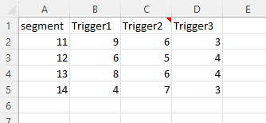

fls_level_threshold:-
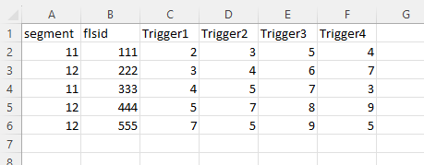

OUTPUT DATA

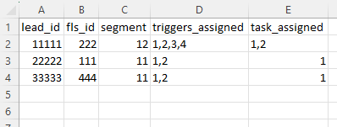

Closure Module

- Step 1: Load CSV File into a DataFrame
Load a CSV file named "optimization_output.csv" into a DataFrame (df). The CSV file is assumed to have a header row.
- Step 2: Filter Rows Based on "task_status"
Filter rows in the Data Frame df to create a new Data Frame filtered_df containing only the rows where the "task_status" column is equal to 1(1 signifies particular fls is occupied with a specific task).
- Step 3: Implement function logic for each task
A function will be defined for every task in the section of config file, for each row in optimized_outpt.csv and lead.csv. The function performs several operations on the data and prints the result if specified conditions are met.
- Step 4: Updating task status
Functions corresponding to each task will be called and the status of the task will be updated.
- Step 5: Split Unique ID
For each unique ID, split it into its components: fls_id, task_no, lead_id, and proc_date.
- Step 6 Update task_status
If the condition meets task_status of the corresponding fls_id will be updated as closed.

Optimization

API and UI: TBD

Config Validation

We will validate all the config files before the pipeline runs.

Threshold logic Config

The threshold logic file is trigger specific; it contains the logic to calculate the threshold for specific triggers.
Lambda function will validate the config file to ensure its correctness.
For any mistakes SNS message will be sent automatically to the stake holders so that they can take necessary actions beforehand.
Below are the columns required to calculate the threshold with Individual validations.

Column name | Description | Validation logic
sql_Thres_Query_Logic | Contains the SQL Query to Calculate the Threshold.  E.g. below is Query to Calculate the threshold for Trigger 1.  select fls_id, datediff (lead_generation_date, meeting_setup_date) +1 AS trigger1_fls_level_thresold from lead_table | Below are the steps to validate the SQL Query  Step1: In step 1 we will check the syntax of SQL query by parsing it using SQLparse python library to detect any syntax  Step 2: In step 2 we will Execute the Query with Zero (1) limit in try catch block to ensure the correctness of SQL query.  If we are able to execute query successfully means query is correct, if any error occurred means query is not valid
Activation_Flag | Flag to Activate and deactivate the threshold | Should be Boolean value can contain 0, 1 or True, False
Operation | Contains the group by or aggregation function | Should contains only Allowed Operation  e.g. ['Average','Business','Count','Sum']  If the value is Business means no need to calculate the threshold. fixed threshold in config file.
Analysis_Period | Period of time (Number of days) to fetch the most recent data | Value should be numeric (Integer) and Greater than 0
Segment_Threshold_1_Requirement_Flag | Requirement flag whether segment level threshold required or not | Should be Boolean value can contain 0, 1 or True, False
FLS_Threshold_2_Requirement_Flag | Requirement flag whether FLS level threshold required or not | Should be Boolean value can contain 0, 1 or True, False
Num_thresholds_required | Total number of threshold required for specific trigger | Should be Integer value either 1 If any of the FLS/segment level threshold required, 2 if both the threshold required or 0 if none of the FLS/Segment level required

Source Code

Step 1. Read the config file
import pandas as pd
pandas_df_config = pd.read_excel ('config_template.xlsx', sheet_name="1.a Threshold Logic Config")
Step 2. Create the validation function
# TO the syntax of SQL query by using SQL parse library
def validate_sql_query_syntax(sql_query):
try:
# parsing the SQL query
parsed = sqlparse.parse(sql_query)
return True #No Syntax error if parsed
except Exception as e:
# call the SNS notification to send to notify the error
print (f"there is a syntax error in the query: {e}")
return False

def validate_sql_query_with_Zero_limit(sql_query):
try:
if not validate_sql_query_syntax(sql_query):
return False
# database connection
# excecute SQL query with limit 0
# close the connection
return True
except Exception as e:
# If an exception is raised, there is an issue with the query
# call the SNS notification
print (f"Query Error: {e}")
return False

def data_type_validation(input_value, expected_data_type):
try:
if expected_data_type == "int":
int(input_value)
elif expected_data_type == "float":
float(input_value)
elif expected_data_type == "str":
str(input_value)
elif expected_data_type == "bool":
input_value = input_value.strip().lower()
if input_value in {"true", "false", "1", "0"}:
bool(input_value)
else:
raise ValueError("Invalid value")
else:
raise ValueError("Unsupported data type")
except (ValueError, TypeError):

# call sns notification here
return False
return True

def ChecK_sum_of_threshold_required(num_threshold_required, segment_threshold, fls_threshold):
try:
# check datatype of column
if not data_type_validation(num_threshold_required, 'int'):
return False;
# checking if sum is valid
if (int(segment_threshold)+int(fls_threshold)) == int(num_threshold_required):
return True
else:
return False
except Exception as e:
# call the sns notification
return False

def check_thres_required(input_value):
try:
if int(input_value) != 0 and int(input_value)!=1:
return False;
except ValueError as e:
# call the sns nootification
return False;
return True

Step 2. validate the config file
try:
validation_flag = True
for i in range(len(thresold_config_df)):
print(i)
# checking if sql query is valid
sql = thresold_config_df["sql_Thres_Query_Logic"][i]
trigger_id =thresold_config_df["Trigger_id"][i]
if not validate_sql_query_with_Zero_limit(sql):
validation_flag = False
print(f"Error: The SQL query is not valid for trigger {trigger_id}.")

# checking if Activation_Flag is valid
if not thresold_config_df["Activation_Flag"][i].strip().lower() in {"y", "n", "1", "0"}:
validation_flag = False
print(f"Error: Invalid Activation_Flag for trigger {trigger_id}.")
raise ValueError(f"invalid Activation_Flag for trigger {trigger_id}")

# checking if operation is valid
if not thresold_config_df["Operation"][i] in Allowed_operations:
validation_flag = False
print(f"Error: Operation is not allowed for trigger {trigger_id}.")
raise ValueError(f"Error: Operation is not allowed for trigger {trigger_id}.")

if not data_type_validation(thresold_config_df["Analysis_Period"][i], 'int'):
validation_flag = False
print(f"Error: Analysis_Period should be an integer value for trigger {trigger_id}.")

if check_thres_required(thresold_config_df["Segment_Threshold_1_Requirement_Flag"][i]) and check_thres_required(thresold_config_df["FLS_Threshold_2_Requirement_Flag"][i]):
if not ChecK_sum_of_threshold_required(thresold_config_df["Num_thresholds_required"][i],thresold_config_df["Segment_Threshold_1_Requirement_Flag"][i],thresold_config_df["FLS_Threshold_2_Requirement_Flag"][i]):
validation_flag = False
print(f"Error: The value of Num_thresholds_required is not correct for trigger {trigger_id}.")
else:
validation_flag = False
print(f"Error: The values of columns Segment_Threshold_1_Requirement_Flag and FLS_Threshold_2_Requirement_Flag should be 0 or 1 only for trigger {trigger_id}.")

# Check if trigger id is valid

if not validation_flag:
print("Info: The current version of the file from S3 will be deleted automatically.")
# delete current version of file from s3

except Exception as e:
# delete the current version of s3 file
# send the sns notification with error
print (error occurred as {str(e)}")

IEARN CI/CD Setup.

- Creation of One repos in Bitbucket.
- Repo will have 5 folders for each glue job script.
- Repo will contain one CFT file for glue job component and a build spec file needed for code build.
- Code pipeline to run the pipeline whenever it detects changes in source repo code.
- Code build will run to copy glue job script to s3 bucket and update the script location in CFT file for the job which has been updated in the repo.
- Code deploy to deploy Glue job using cloud formation template.
- SNS to send notifications on success/failure of the pipeline.

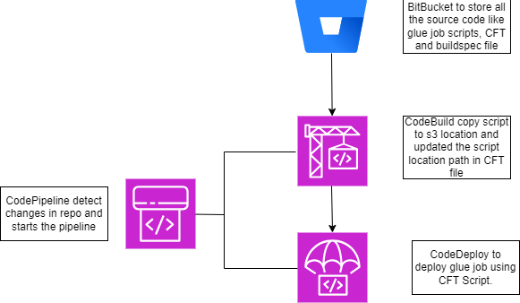

Job Scheduling – NA

Code Repository and branching
repositories will be used as per following table –

Repo Name | Technology | Description
Iearn_glue | Glue | Keep All glue jobs code
Iearn_rds | RDS | Keep all DDL queries
Iearn_cicd | Code Pipeline | All scripts related to CICD / code pipeline

Code Repository and branching

Branching

Branch types | Naming convention | Purpose | Migration strategy | CICD | Trigger for CICD
Master Branch | main | Final code which runs in production/live environment | At the time of go live, UAT branch should be merged into main | Yes | manual
UAT branch | UAT | code which is under UAT testing | At the time of UAT testing, merge dev branch into UAT | Yes | manual
Dev branch | dev | code which is under development, in case multiple developers are working, it will be merged code | Before moving code into UAT environment, all respective feature branches should be merged into Dev | Yes | PR request
Feature branch | feature/<dev initial> | code branch specific to the developer's work | At the start of development | No | Na

AWS Job scheduling and rerun:

- Lambda Function (validation logic) - this will be generic function which will be scheduled in a particular time post all required files reach in S3 project bucket.
- Glue jobs (raw to input folder to RDS) - All glue jobs orchestration will be done using glue workflow. For glue jobs rerun or retry is fixed to 1.
- RDS instance uptime will be for 12 hours considering pick request time.

Job Run Frequency:

Job no | Job Name | Ideal Frequency | Task done
1 | Lambda job | Once in a day | Validation of input custom files
2 | Threshold glue job | Once in a month | Generate the threshold files for further use.
3 | Other glue jobs in workflow | Once in a day | Closure,optimizatio and task & trigger

Appendix:

